GENERIC DEMO:

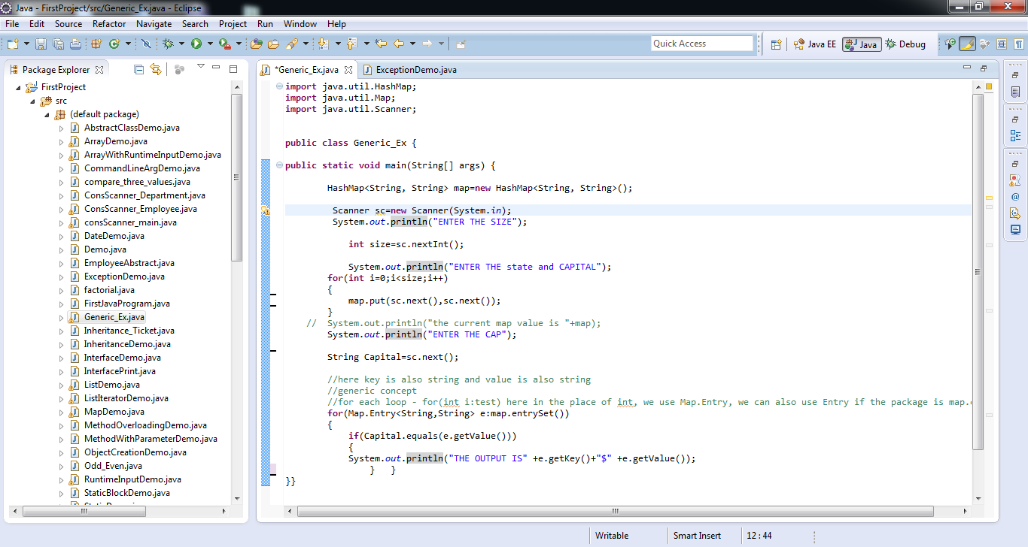

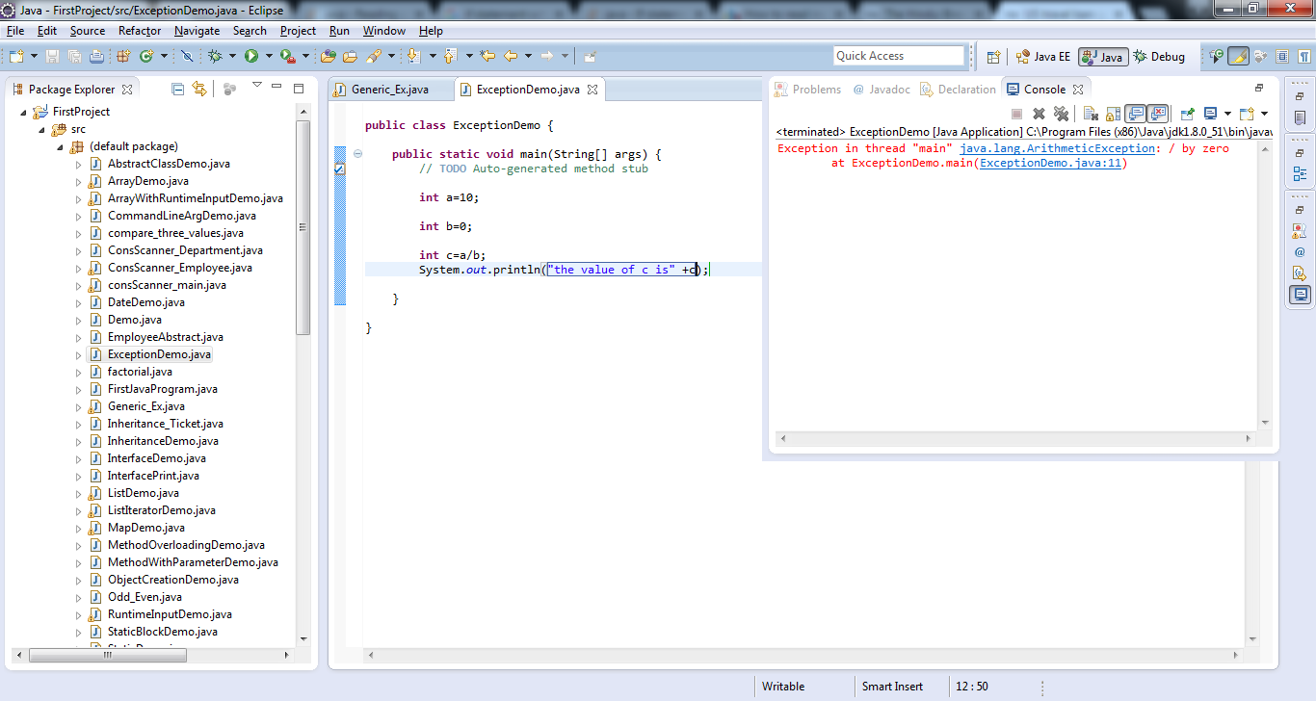

Now the exception is handle, the catch block will be executed only when there is an exception:

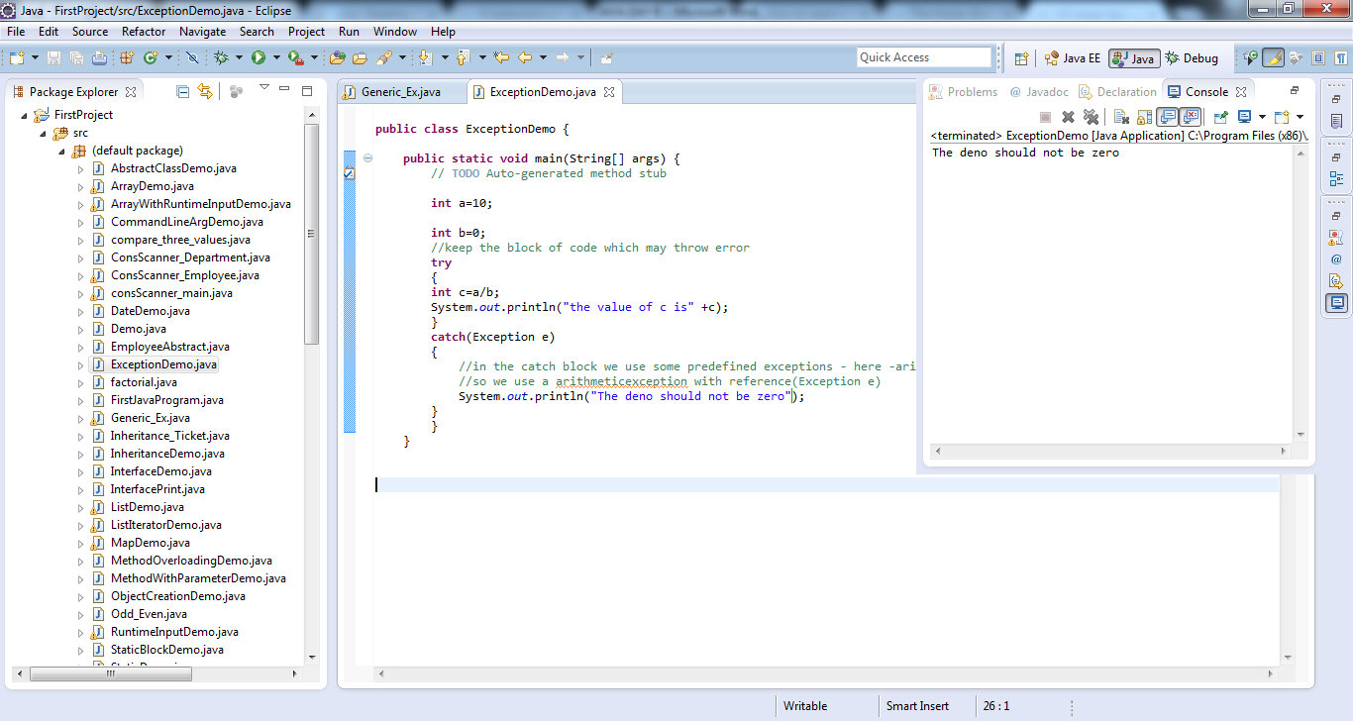

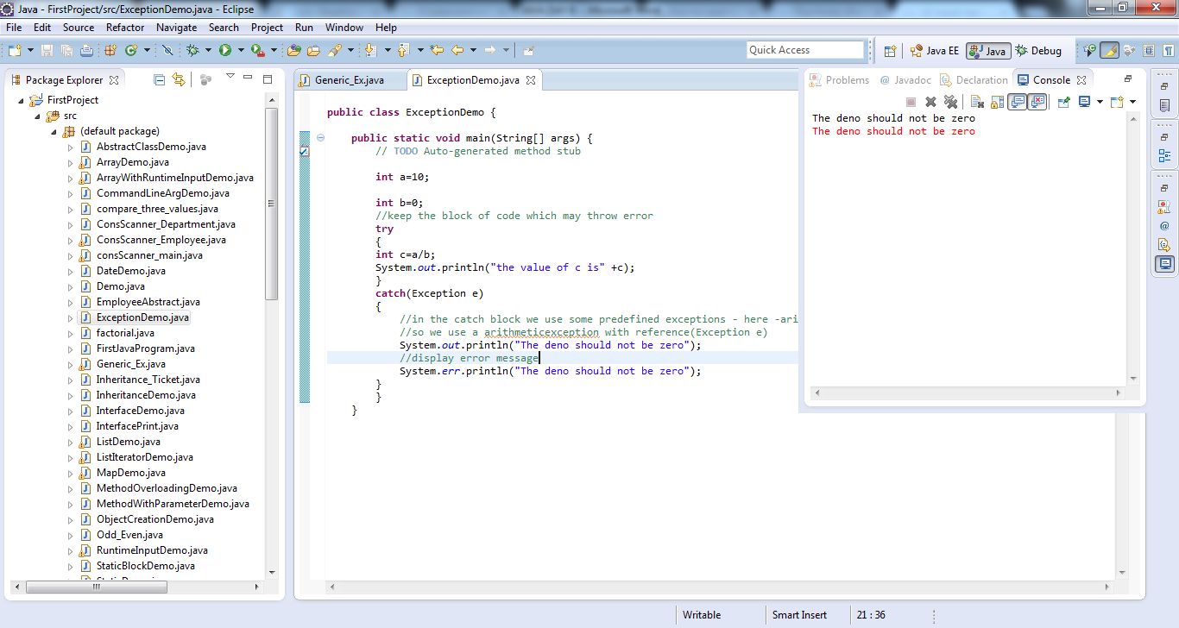

Number Format Exception:

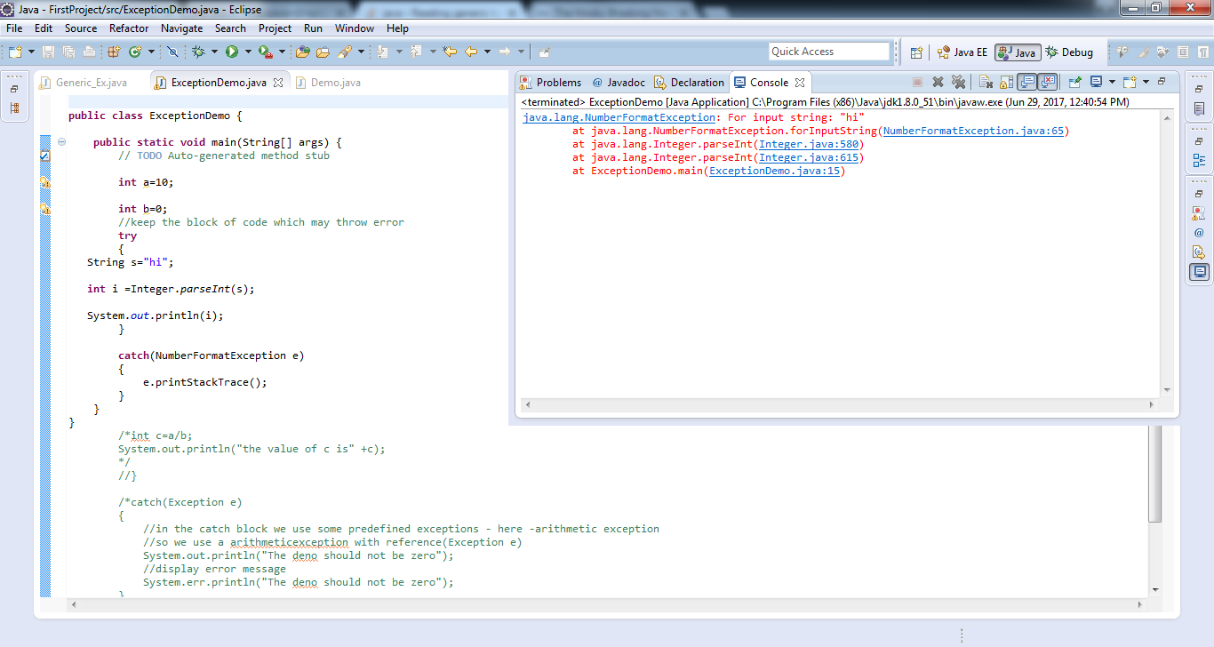

**Refer this url for “FINALLY”**

https://www.javatpoint.com/finally-block-in-exception-handling